**How to View Amira Assessment Status**

To see who completed click on tracking report

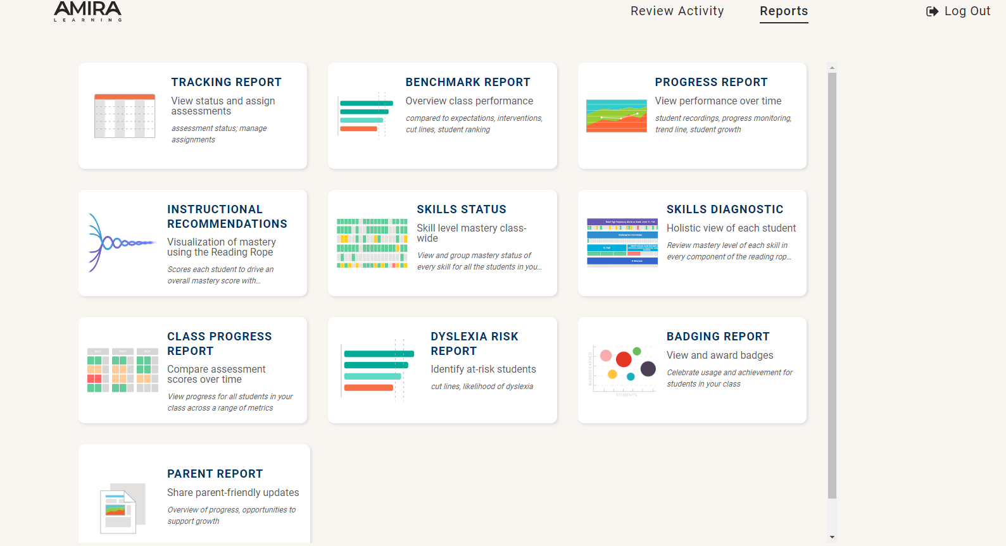

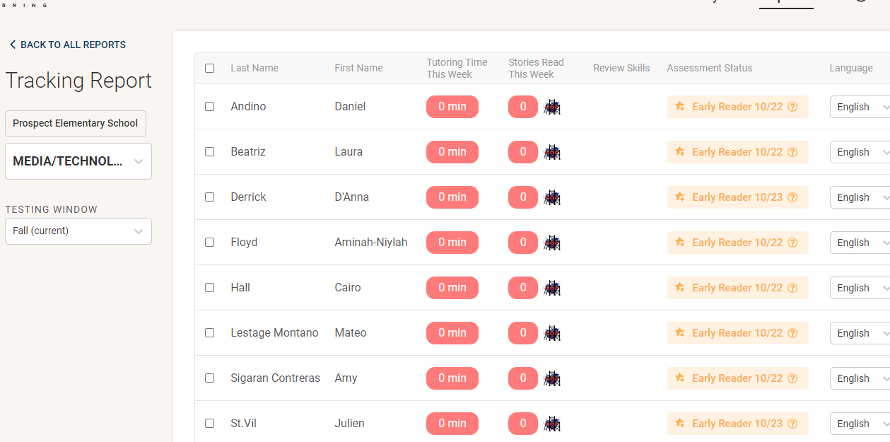View the assessment status column.  
If it says scheduled the child did not complete yet.

If you see early reader/or complete the child completed the assessment.

If you see in progress the child needs to log back in and complete until the end. (check mark on book)

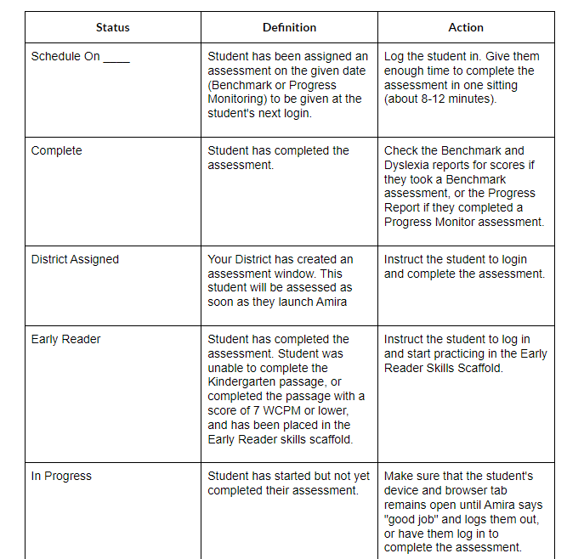

<https://vimeo.com/showcase/10491813/video/840226848>

**How to View Amira Assessment Results**

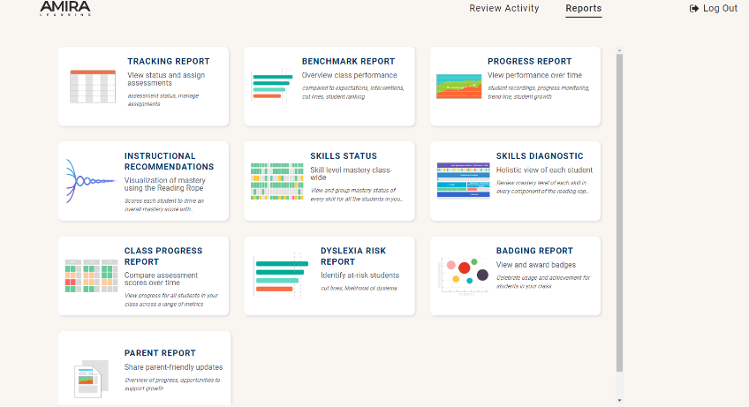Click on the benchmark reports tab

You will see how all of the students did broken down by percentile.

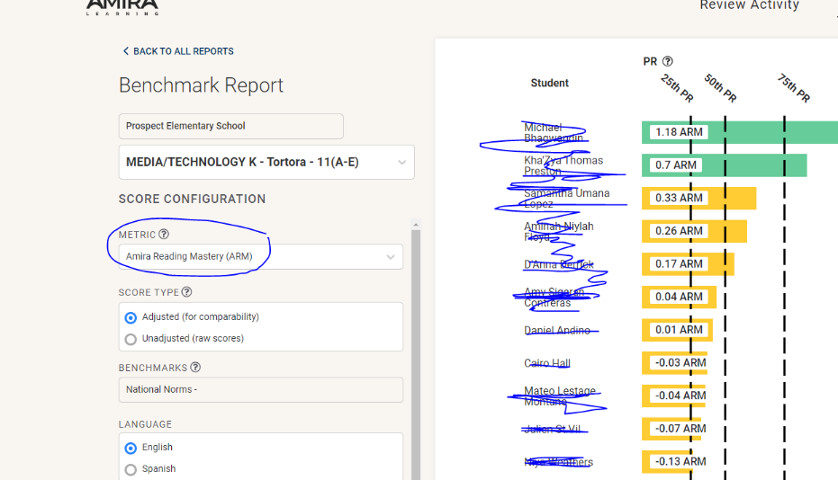

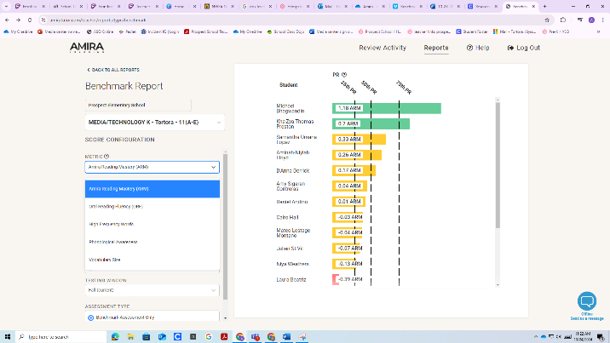

Look at the different metrics and

See how they did in the areas:

ARM, ORF, high frequency, phonological

Awareness, vocabulary

<https://vimeo.com/showcase/10491813/video/855078582>